**Recent Field Experience with Extremely Low NOx Burners in Difficult Service Heaters**

Jeff Lewallen [jeff.lewallen@clearsign.com](mailto:jeff.lewallen@clearsign.com); Dr. Jim Deller [jim.deller@clearsign.com](mailto:jim.deller@clearsign.com); Carley Hockett [Carley.Hockett@clearsign.com](mailto:Carley.Hockett@clearsign.com); Kirk Meinershagen [Kirk.Meinershagen@clearsign.com](mailto:Kirk.Meinershagen@clearsign.com); Steve Sock [steve.sock@clearsign.com](mailto:steve.sock@clearsign.com)

# ABSTRACT

ClearSign Technologies has recently commissioned multi-burner installations in two crude unit heaters. These burners utilize a distal flame holder which, in conjunction with other design elements, produce NOx emissions of less than 9 ppm corrected to 3% excess oxygen and CO emissions less than 2 ppm with effectively no measured VOC. In other operating conditions, burners of the same design have achieved less than 5 ppm dilution corrected NOx in fielded operation.

These installations are notable because the fuel composition is highly variable with hydrogen content that can exceed 80%. The hearth heat intensity of these existing heaters is well above API standards (358,185 and 623,628 Btu/h-ft2 respectively) for a new heater design. These challenges make this cases study particularly germane to current industry challenges of firing fuel with increased hydrogen content in older fired heaters while maintaining or improving NOx emissions.

The design of the burners is presented with a discussion of both the NOx reducing features and accommodations for wide ranging high-hydrogen operation of partially premixed burners and high hearth heat intensity. Factory acceptance test data and photographs are compared to the source test data of the installed applications with an analysis of differences.

# CHALLENGE

March 2023, a refinery reached out to ClearSign to revisit a burner solution to their NOx emissions problem in their Prefractionator Reboiler and Crude Heater in their Crude Unit. The two companies had discussed this opportunity in 2020 and 2021 and the ClearSign technology was deemed too new and ultimately the refinery decided to pursue a post combustion, selective catalytic reduction (SCR) system for their furnaces. While a proven NOx reduction technology, the refinery faced compliance pressure to reduce emissions by the end of 2023 or the local air district could impose significant fines. The SCR supplier could not meet the schedule to install and have the unit operational by the end of 2023.

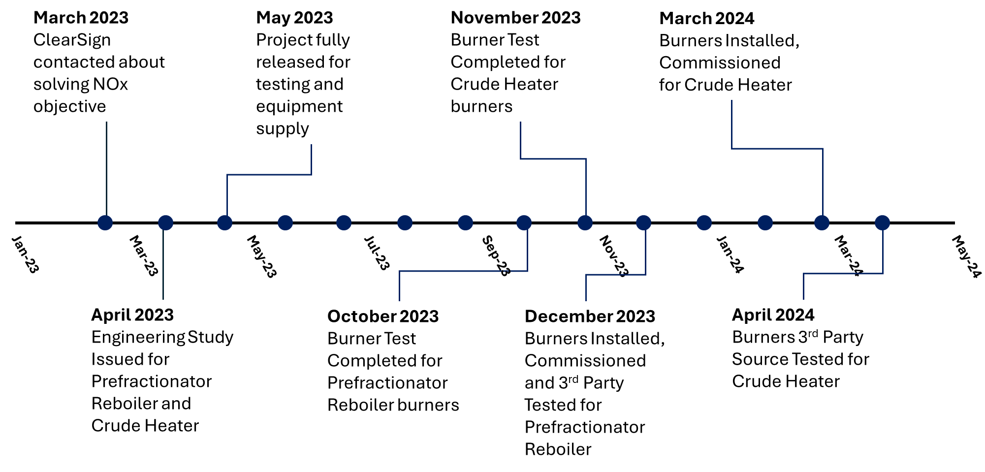

**Figure 1: Timeline**

While the refinery continued to work on the SCR solution, they gave ClearSign an order for an engineering study in April 2023 to develop drawings, engineering documents and a control narrative. The challenge would be to design, conduct a performance test, fabricate, deliver, install, commission, and perform a third-party source test before the end of the year for the Prefractionator Reboiler and complete third-party source testing on the crude heater by April 2024. Ultimately, the SCR system could not meet the project deadlines and the refinery decided to move forward with the burner supply and eliminate the SCR from the project.

# DESIGN CONDITONS

The challenge with the heaters was the range of fuels and the design conditions of the heater. The design conditions are shown below in Table 1. In the table, areas of concern are shaded in yellow and red depending on the severity of the issue. The prefractionator reboiler had slightly high heat intensity (HHI), heater design heat release divided by the cross are of the floor of the heater, but the burner to coil spacing and ratio of burner circle diameter divided by tube circle diameter (BCD/TCD) does not meet the criteria outline in the latest edition of Table 2 shows the range of expected fuel gases. These values show a potential for flame rollover into the tubes leading to high tube metal temperatures (TMT’s). The crude heater, on the other hand, has an extremely high HHI at 623,628 Btu/h-ft2 (API 560 recommends 300,000 Btu/h/ft2), poor burner to burner spacing and poor burner to coil spacing. This heater could have flame rollover into the tubes, longer than anticipated flame lengths and present a challenging environment in which to reduce NOx emissions. Both heaters were required to meet 30 ppm (0.036 lb/MMBtu HHV) NOx emission limits. Due to regulatory changes, the heaters had to be below at least 15 ppm (0.018 lb/MMBtu HHV) to operate under new emissions guidelines for the air district.

**Table 1. Design conditions**



Table 2 shows a snapshot of the fuel range over which the burners were expected to operate.

**Table 2: Fuel gas compositions**

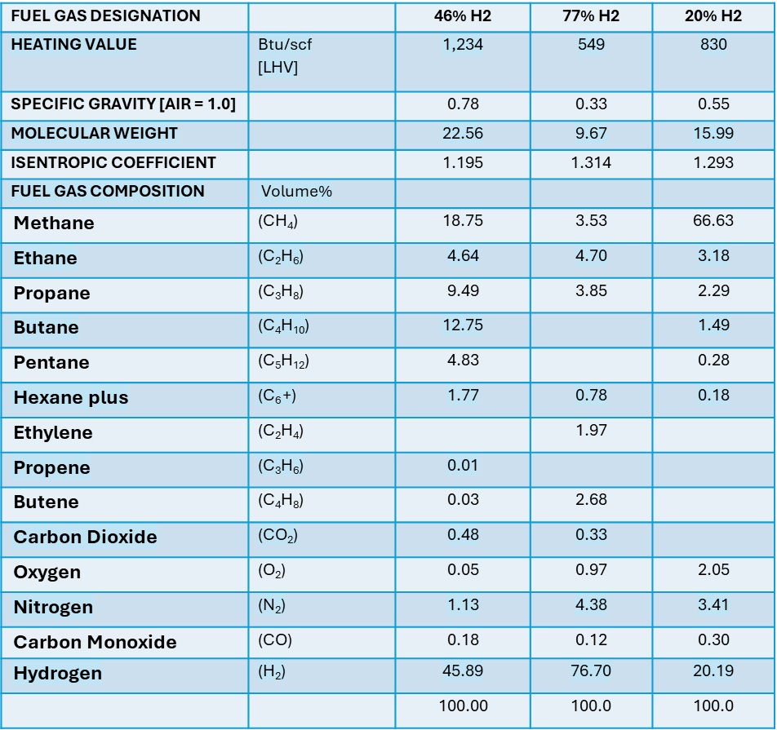

# DESIGN APPROACH

For the prefractionator reboiler, ClearSign decided to utilize our premix burner, ClearSign Core 8P. This would allow the burner to take advantage of the premix design and allow the NOx emissions to be reduced with an increase in excess air. This design, however, is not conducive to the hydrogen range with which it would have to contend with on the project. It was decided to utilize mixing steam with the fuel to dilute the fuel gas to mitigate the potential for flashback.

For the crude heater, due to the high HHI, ClearSign decided to use a hybrid design, ClearSign Core 8R which is more resistant to flashback with higher hydrogen fuels. Because of the high hydrogen fuel and the high HHI, it was decided to utilize steam mixed with the fuel. This was done again to dilute the fuel gas as well as provide some insurance on the NOx due to the uncertainty of the response of the NOx reduction with such a high heat intensity radiant section.

As illustrated in Figure 2, the premix model, ClearSign Core 8P, the fuel and air are constrained in concentric mixing tubes to control equivalence ratios in each zone as well as the mixing of flue gas in the burner.

The ClearSign Core 8R, which was installed in the high HHI heater utilizes a different approach which includes altering the mixture of fuel, air and flue gas. The design mixes a portion of the fuel with the central air mixing tube while the balance of the fuel is distributed into the stage cans allowing the fuel to only mix with fuel gas. The last zone is air only. This improves the burners’ resistance to flashback, especially with high hydrogen fuels, and allows it to still generate low NOx emissions.

**Figure 2: Illustration of the differences in the ClearSign 8P and 8R models**

# TEST RESULTS

With the burner configurations defined, single burner tests were conducted to optimize the burner details and set the steam to fuel ratio. The burner tests established operating parameters such as the steam to fuel ratio, air door settings and air to fuel ratio. The charts below show the impact of excess air on NOx formation. For this furnace a 50% allowance on NOx emissions was assessed in anticipation of the difference between a single burner test furnace and the destination heater. With a 9 ppm NOx guarantee for the prefractionator reboiler, the burner would need to demonstrate NOx less than 6 ppm in the test furnace to provide confidence that the 9 ppm NOx guarantee would be met in the field, and as measured by a 3rd party source test. The 50% contingency from single burner test NOx allows for the effects of burner-to-burner interaction and other variables that cannot be covered in a factory test.

Figure 3 shows the NOx levels with varying excess air as measured in the burner test furnace, with NOx levels corrected to 3% O2. This data shows that the oxygen level in the furnace would need to be maintained at 3.5% O2 (volume, dry) to allow enough margin on the NOx guarantee to meet the 9ppm requirement in the field. A feature of these burners, and generally with premixed technology, is that the NOx reduces as the excess air is increased. This allows the technology to not only generate low emissions, but also has an in-field adjustment capability should the NOx be higher than predicted when installed in a destination furnace.

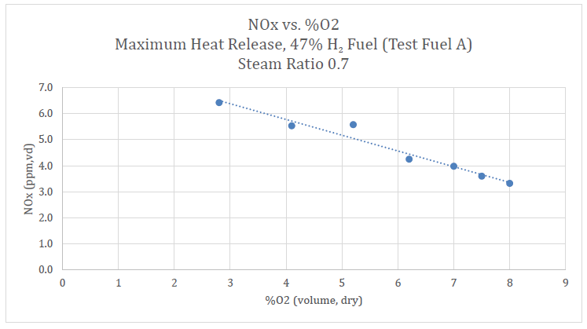

**Figure 3: ClearSign Core 8P NOx response to oxygen level in the flue gas**

The second burner to test was the ClearSign Core 8R. The graph (Figure 4) below shows the variation in NOx emissions from this burner with changing levels of excess air. The configuration of this burner is different from the previous burner and the NOx vs excess air response is more similar to a traditional raw gas or diffuse gas burner in which the NOx typically reduces as the excess air is reduced.

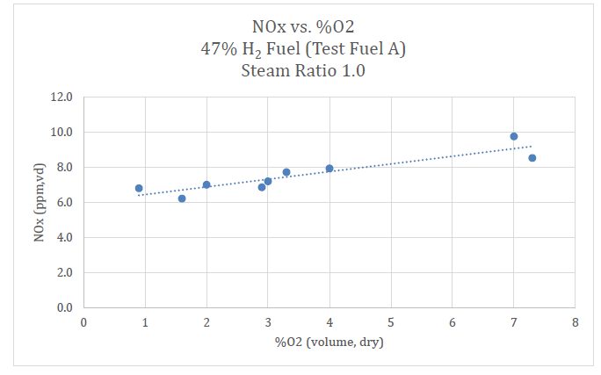

**Figure 4: ClearSign Core 8R NOx response to oxygen level in the flue gas**

With a guarantee of 15 ppm, the goal was to demonstrate NOx less than 10 ppm in the test furnace using the same allowance as was applied to the previous ClearSign Core 8P test. In testing the burner was shown to operate well over a wide range of excess air levels, with corresponding effects on the NOx emissions. Due to the high HHI of the destination heater, and the extensive operating flexibility of this burner the target oxygen for field operation was set 3% O2. Operating at this level provided an allowance of nearly 100% increase in NOx between the single burner test and the 15 ppm permit level required in the destination heater, and as would be measured by a 3rd party source testing company.

# FIELD RESULTS

In December 2023, the ClearSign Core 8P burners were installed in the prefractionator reboiler, started up and a 3rd party source test was scheduled to confirm the permitted NOx level was met. Prior to the source test the stack emissions were measured for NOx. The target flue gas oxygen was trimmed in between 3.5 to 4.5% and the test was conducted. In accordance with US EPA Method 7E, the NOx was recorded at 8.41 (corrected to 3%O2) @ 3.5 to 4.5% O2 (exit radiant section) 6% O2 out the stack. While the convection section had a significant leak, the ClearSign burners were still able to meet the 9 ppm NOx guarantee. The impact on NOx due to air leakage was approximately 40% but still came in below the permitted level. Again, the excess air could be increased if additional room was desired.

The crude heater was retrofitted with the ClearSign Core 8R burners in March 2024 and in April 2024, the crude heater NOx levels were measured in a formal 3rd party source test. In accordance with US EPA Method 7E, the NOx was recorded at 13.6 ppm (corrected to 3%O2). During the testing period excess oxygen was measured at between 1% and 2% at the exit of the radiant section, and at 4% O2 in the stack. Despite the air leakage in the convection section, the NOx met the guarantee. Because of the extremely high HHI the operating excess air was reduced to low levels to achieve the NOx levels required to satisfy the 15 ppm permit requirements. Compared to the test data, the NOx nearly doubled due to the impact of air leakage and the very compact radiant section. Fortunately, due to the operating range of the burners the burner excess air levels could be adjusted to maintain the NOx required in service.

# CONCLUSION

The ClearSign Core burners were optimized in test and installed in the customer site in a very tight time frame, and in challenging applications including wide ranging hydrogen concentrations in the fuel gas, air leakage into the heater and extremely high fired hearth intensity in one of the destination heaters. This was in part due to the strengths of the different configurations of the ClearSign Core burner technologies and extensive control over NOx emissions achievable by varying operating excess air levels, and the ability to compress the installation schedule enabled by the burner footprint enabling the existing heater floor cutouts, bolting patterns to be utilized and the modular design of the burners enabling quick and easy installation.

The comprehensive data collected during the factory testing provided a basis for tuning the burners in the field heaters to meet the required NOx emissions. The scaling factor or allowance of an anticipated 50% increase in NOx levels between the test furnace and field installation was found to be reasonable for the normal hearth firing intensity of 358,185 Btu/h-ft2 but should be increased to approximately 100% for the much higher hearth firing intensity of 623,628 Btu/h-ft2. Fortunately, the burner design provides the ability to accommodate this increased NOx scaling.

ClearSign’s burner installations have consistent operation with mid-single digit NOx levels significantly below the levels cited in this case study and have provided the bases for setting two BACT thresholds in early 2024. The burners are designed to be easy to install and to operate like any other burner, and give operating refineries another option when evaluating technologies to reduce NOx emissions across a plant, and especially when seeking an alternative to installing an SCR.

**References**

American Petroleum Institute. (2016). *API Standard 560: Fired Heaters for General Refinery Services* (5th ed.). Washington, DC: Author.

U.S. Environmental Protection Agency. (2017). *EPA Method 7E: Determination of Nitrogen Oxides Emissions from Stationary Sources (Instrumental Analyzer Procedure)*. Washington, DC: Author.